Club App

**The app is very slow to respond to commands**

Post Vacancy

* **Phone number – wrong – should be other and the phone number associated with account**
* **Email – wrong – should be other and the Email associated with account**
* **Push notification not working when job is posted**
* **Post Job Screen**
  + When user selects shifts – select license box should be removed
  + Category Box – Should only show: (remove the rest)
    - Group Fitness Exercise – **CHANGE NAME TO GROUP FITNESS CLASSES**
    - Shifts
  + Type Box – Add in:
    - Other
  + Remove end time Replace with Duration Length – User inputs how many minutes or hours
  + When Shifts are selected in Category – remove the following boxes
    - Number of classes
    - Session
  + Remove Payment Type and Amount

Jobs History

* Change name to Job History
* Completed jobs replace **Offers:** with Accepted By: (Instructors Name) on front page

Instructors

* Under favourite – add in employee (this allows user to add the instructor as employee)
* Default every instructor as non employee

Favourite list

* Does not allow me to click into instructors profile.

Instructor Profile

* Text or message link does

Calendar

* Can we allow the calendar view to be changagble – allow user to view calendar as weekly, monthly and annually

Profile Page

* Does not allow me to edit club profile
* Appearance is ok

Instructor App

* **App is very slow to respond**

Profile

* Picture is not working on profile.
* Profile does not allow you to upload CV or Resume
* Next to edit symbol write the words edit

Job Vacancies

* Search filters – next to Group Fitness Exercises, Shifts and Creche there is a symbol (remove this symbol) – Search filters should only show Group Fitness Classes and Shifts Remove the rest

Selecting a Job to View

* Change Header of Page (currently Details) to the name of the job
* Booking Details should show
  + Duration : (minutes or hours that has been chosen from the club)
* Jobs that are classed as Shifts – Remove Class
* Jobs that are classed as Shifts – Should show in the booking details – Type
* Jobs that are classes as Group Fitness Classes – Should show in the Booking Details – Type and License
* Push Notification is not working with the accepting, decline, or my offer
* Jobs should be moved to history once you have selected one of the above

My Availability

* Update Availability should go straight to Add Availability – Remove All Availabilities
* All Availabilities should be a button under Update Availabilty
* Set Date – Today button does not work
* Set Up Repeat – Remove Always – Remove Every Weekend – Remove Every Weekday – only show
  + One Time
  + Every Week (This function should make that particular day chosen (i.e. Monday) every week available or unavailable as chosen by instructor
* Once I hit Update – User should be taken to My Availability Screen and should say Availibility Saved Successfully (as already prompted)

Job History

* Add filters – Accepted, Declined, My Offer, Ignored

Clubs

* Remove add a comment to this instructor
* Club profiles seem to mirror instructor profile – this is incorrect – i.e. area willing and experience should not be there ….

**Sample templates online website club registration**

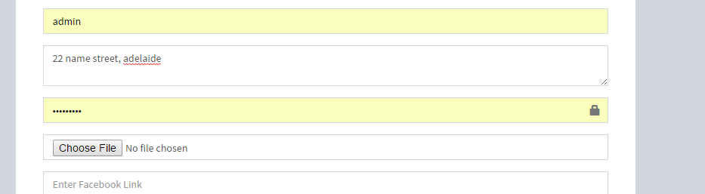

Admin and I am assuming preselected password? This is odd…. Not sure what these fields are – when you remove admin – it comes up as Map location? Why?

Choose file – doesn’t explain why or what to upload?

Once registered email does not come through? Or is very slow…